CUSTOMER SHOPPING BEHAVIOR ANALYSIS
Using Python, PostgreSQL, Neon and Power BI
Made By: Anurag Mishra
TABLE OF CONTENTS
- Abstract
- Introduction
- Problem Statement
- Objectives
- Dataset Description
- Tools and Technologies Used
- Data Preprocessing
- Feature Engineering
- PostgreSQL and Neon Database
- SQL Analysis and Results
- Power BI Dashboard
- DAX Measures
- Overall Findings
- Business Recommendations
- Limitations
- Future Scope
- Conclusion
- Screenshots / Results
- References

1. ABSTRACT
This project focuses on analyzing customer shopping behavior using a dataset containing 3,900 customer records. The project combines Python-based data preprocessing, PostgreSQL database management through Neon, SQL-based business analysis, and Power BI visualization.
The dataset was cleaned by handling missing review ratings, standardizing column names, creating age groups, converting purchase frequencies into numerical day values, and removing a redundant promotional-code column after verifying its relationship with discount application.
SQL queries were then used to analyze gender-wise revenue, discount-based purchasing behavior, product ratings, shipping preferences, subscription behavior, discount rates, customer segmentation, product popularity, repeat buyers, and revenue contribution by age group.
Finally, Power BI was used to create an interactive dashboard containing customer, sales, revenue, subscription, category, and age-group insights.
The project demonstrates how raw customer data can be transformed into meaningful business information that can support marketing, customer engagement, product planning and business decision-making.

2. INTRODUCTION
Understanding customer shopping behavior is important for businesses because customer data can reveal important patterns about purchasing habits, product preferences, customer loyalty, discounts, subscriptions and revenue.
Businesses can use customer data to answer questions such as:
- Which customer group generates more revenue?
- Which products have better customer ratings?
- Which products are purchased most frequently?
- How frequently are discounts used?
- Do subscribers spend more than non-subscribers?
- Which customers are new, returning or loyal?
- Which age group contributes the most revenue?
- Do customers using different shipping methods have different spending patterns?
In this project, customer shopping data is analyzed using a complete data-analysis pipeline:
Raw CSV Dataset → Python Preprocessing → PostgreSQL/Neon → SQL Analysis → Power BI Dashboard → Business Insights
The project therefore combines data engineering, database management, data analysis and visualization into one workflow.

3. PROBLEM STATEMENT
How can a company leverage customer shopping data to identify purchasing trends, understand customer behavior, improve customer engagement, and optimize marketing and product strategies?
The project addresses this problem by cleaning customer data, storing it in a relational database, performing SQL-based analysis and presenting important findings through an interactive Power BI dashboard.

4. OBJECTIVES
The main objectives of the project are:
- To understand the structure of customer shopping data.
- To clean and preprocess the dataset.
- To identify and handle missing values.
- To standardize the dataset for analysis.
- To create useful derived features.
- To store the processed dataset in PostgreSQL using Neon.
- To perform business-oriented SQL analysis.
- To analyze customer purchasing behavior.
- To identify high-rated and frequently purchased products.
- To analyze discount usage.
- To compare Standard and Express shipping behavior.
- To compare subscribers and non-subscribers.
- To segment customers based on previous purchases.
- To analyze repeat buyers.
- To study revenue contribution by age group.
- To create an interactive Power BI dashboard.
- To generate useful business recommendations from the results.

5. DATASET DESCRIPTION
5.1 Dataset Name
customer_shopping_behavior.csv
5.2 Dataset Size
The dataset contains:
3,900 customer records
The following SQL query was used:
SELECT COUNT(*) FROM customer;
Result:
3900
5.3 Dataset Attributes
Attribute | Description
customer_id | Unique customer identifier
age | Age of the customer
gender | Gender of the customer
item_purchased | Product purchased
category | Product category
purchase_amount | Amount spent on the purchase
location | Customer location
size | Product size
color | Product color
season | Shopping season
review_rating | Customer review rating
subscription_status | Subscription status
shipping_type | Type of shipping selected
discount_applied | Whether a discount was applied
previous_purchases | Number of previous purchases
payment_method | Payment method
frequency_of_purchases | Frequency of purchases
age_group | Derived customer age group
purchase_frequency_days | Derived purchase-frequency value in days

6. TOOLS AND TECHNOLOGIES USED
Tool / Technology | Purpose
Python | Data preprocessing
Pandas | Data manipulation and cleaning
PostgreSQL | Relational database
Neon | Cloud PostgreSQL database
SQL | Business analysis
Power BI | Data visualization and dashboard
DAX | Power BI calculations
Jupyter / Google Colab | Python execution environment

7. DATA PREPROCESSING
The raw CSV dataset was first loaded into Python using the Pandas library.
import pandas as pd

df = pd.read_csv('customer_shopping_behavior.csv')
The dataset was initially inspected using:
df.head()
df.info()
df.describe(include='all')
df.isnull().sum()
These operations helped understand the dataset structure, data types, statistical information and missing values.

7.1 Handling Missing Review Ratings
Missing values in the Review Rating column were filled using the median review rating within each product category.
df['Review Rating'] = df.groupby('Category')['Review Rating'].transform(
lambda x: x.fillna(x.median())
)
Reason for using median
The median was selected instead of the mean because the median is less affected by extreme values or outliers.
This makes it a suitable choice for filling missing review ratings.

7.2 Standardizing Column Names
The column names were converted to lowercase:
df.columns = df.columns.str.lower()
Spaces were replaced with underscores:
df.columns = df.columns.str.replace(' ','_')
The purchase amount column was renamed:
df = df.rename(
columns={'purchase_amount_(usd)':'purchase_amount'}
)
This produced cleaner column names and made them easier to use in SQL queries.

8. FEATURE ENGINEERING
Feature engineering was performed to create additional useful information from existing columns.

8.1 Creating Age Groups
Customers were divided into four age groups using quartile-based binning.
labels = ['Young Adult','Adult','Middle-aged','Senior']

df['age_group'] = pd.qcut(
df['age'],
q=4,
labels=labels
)
The resulting age groups were:
- Young Adult
- Adult
- Middle-aged
- Senior
This feature was later used for revenue and sales analysis.

8.2 Converting Purchase Frequency into Days
The categorical purchase frequency was converted into numerical days.
frequency_mapping = {
'Fortnightly': 14,
'Weekly': 7,
'Monthly': 30,
'Quarterly': 90,
'Bi-weekly': 14,
'Annually': 365,
'Every 3 months': 90
}

df['purchase_frequency_days'] = df[
'frequency_of_purchases'
].map(frequency_mapping)
This converts purchasing frequency into a numerical representation that can be used for further analysis.

9. REMOVAL OF REDUNDANT DATA
The relationship between discount_applied and promo_code_used was checked using:
df[['discount_applied','promo_code_used']]
The equality between the two columns was also checked:
(df['discount_applied'] == df['promo_code_used']).all()
Since the two columns contained the same information, promo_code_used was removed.
df = df.drop('promo_code_used', axis=1)
This helped reduce redundancy in the dataset.

10. POSTGRESQL AND NEON DATABASE
After preprocessing, the cleaned dataset was uploaded into a PostgreSQL database hosted on Neon.
The database table was named:
customer
The DataFrame was loaded into PostgreSQL using:
df.to_sql(
table_name,
engine,
if_exists="replace",
index=False
)
The database connection was tested using:
SELECT version();
The successful connection confirmed that the PostgreSQL database was ready for SQL-based analysis.

11. SQL ANALYSIS AND RESULTS
Ten SQL-based business questions were analyzed.

Q1. WHAT IS THE TOTAL REVENUE GENERATED BY MALE VS. FEMALE CUSTOMERS?
SQL Query
SELECT gender, SUM(purchase_amount) AS revenue
FROM customer
GROUP BY gender;
Result
Gender | Revenue
Female | 75,191
Male | 157,890
Interpretation
Male customers generated higher total revenue than female customers in the analyzed dataset.
Business Insight
The company can analyze male and female customer segments separately and develop targeted marketing strategies based on their purchasing behavior.
[INSERT SCREENSHOT OF Q1 SQL QUERY AND RESULT HERE]

Q2. WHICH CUSTOMERS USED A DISCOUNT BUT STILL SPENT MORE THAN THE AVERAGE PURCHASE AMOUNT?
SQL Query
SELECT customer_id, purchase_amount
FROM customer
WHERE discount_applied = 'Yes'
AND purchase_amount >= (
SELECT AVG(purchase_amount)
FROM customer
);
This query identifies customers who received a discount and still made a purchase at or above the overall average purchase amount.
The output contains customer IDs and their corresponding purchase amounts.
For example, the output includes customer IDs such as 1337, 1338, 1341, 1347 and 1348, with purchase amounts of 85, 86, 72, 91 and 95, respectively.
Discount Distribution
The dataset contains both Yes and No discount values.
Discount Applied | Number of Customers
No | 2,223
Yes | 1,677
Total | 3,900
Interpretation
The analysis identifies customers who continue to make relatively high-value purchases even when a discount is applied.
Business Insight
These customers can be considered potential targets for future promotional campaigns because they demonstrate purchasing activity despite receiving discounts.
[INSERT SCREENSHOT OF Q2 SQL QUERY AND RESULT HERE]

Q3. WHICH ARE THE TOP 5 PRODUCTS WITH THE HIGHEST AVERAGE REVIEW RATING?
SQL Query
SELECT
item_purchased,
ROUND(AVG(review_rating)::numeric, 2)
AS "Average Product Rating"
FROM customer
GROUP BY item_purchased
ORDER BY AVG(review_rating) DESC
LIMIT 5;
Result
Rank | Product | Average Product Rating
1 | Gloves | 3.86
2 | Sandals | 3.84
3 | Boots | 3.82
4 | Hat | 3.80
5 | Skirt | 3.78
Interpretation
Gloves had the highest average product rating among the top five products, with a rating of 3.86.
Business Insight
Highly rated products can be given greater visibility through recommendations, promotional campaigns and product highlights.
[INSERT SCREENSHOT OF Q3 SQL QUERY AND RESULT HERE]

Q4. COMPARE THE AVERAGE PURCHASE AMOUNT BETWEEN STANDARD AND EXPRESS SHIPPING.
SQL Query
SELECT
shipping_type,
ROUND(AVG(purchase_amount),2)
FROM customer
WHERE shipping_type IN ('Standard','Express')
GROUP BY shipping_type;
Result
Shipping Type | Average Purchase Amount
Standard | 58.46
Express | 60.48
Interpretation
Customers using Express shipping had an average purchase amount of 60.48, compared with 58.46 for Standard shipping.
The difference is:
60.48 − 58.46 = 2.02
Business Insight
Express-shipping customers have a slightly higher average purchase amount in this dataset.
However, this result shows an association and does not prove that Express shipping causes customers to spend more.
[INSERT SCREENSHOT OF Q4 SQL QUERY AND RESULT HERE]

Q5. DO SUBSCRIBED CUSTOMERS SPEND MORE?
SQL Query
SELECT
subscription_status,
COUNT(customer_id) AS total_customer,
ROUND(AVG(purchase_amount),2) AS avg_spend,
ROUND(SUM(purchase_amount),2) AS total_revenue
FROM customer
GROUP BY subscription_status
ORDER BY total_revenue, avg_spend DESC;
Result
Subscription Status | Customers | Average Spend | Total Revenue
Yes | 1,053 | 59.49 | 62,645.00
No | 2,847 | 59.87 | 170,436.00
Interpretation
Non-subscribers form a much larger customer group and generate higher total revenue.
The average spending values are also very close:
- Subscribers: 59.49
- Non-subscribers: 59.87
Business Insight
The data does not show that subscribers have a higher average purchase amount.
The company could investigate ways to improve the value of its subscription program and encourage more customers to subscribe.
[INSERT SCREENSHOT OF Q5 SQL QUERY AND RESULT HERE]

Q6. WHICH 5 PRODUCTS HAVE THE HIGHEST PERCENTAGE OF PURCHASES WITH DISCOUNTS APPLIED?
SQL Query
SELECT
item_purchased,
ROUND(
100.0 * SUM(
CASE
WHEN discount_applied = 'Yes' THEN 1
ELSE 0
END
) / COUNT(*),
2
) AS discount_rate
FROM customer
GROUP BY item_purchased
ORDER BY discount_rate DESC
LIMIT 5;
Result
Rank | Product | Discount Rate
1 | Hat | 50.00%
2 | Sneakers | 49.66%
3 | Coat | 49.07%
4 | Sweater | 48.17%
5 | Pants | 47.37%
Interpretation
Hat had the highest discount rate at 50.00%.
Business Insight
The company should monitor these products to determine whether high discounting is contributing to increased sales and whether the discounts are financially sustainable.
[INSERT SCREENSHOT OF Q6 SQL QUERY AND RESULT HERE]

Q7. CUSTOMER SEGMENTATION BASED ON PREVIOUS PURCHASES
Customers were segmented using the following criteria:
Previous Purchases <= 1 → New
Previous Purchases 2–10 → Returning
Previous Purchases > 10 → Loyal
SQL Query
WITH customer_type AS (
SELECT
CASE
WHEN previous_purchases <= 1 THEN 'New'
WHEN previous_purchases BETWEEN 2 AND 10 THEN 'Returning'
ELSE 'Loyal'
END AS customer_segment,
COUNT(*) AS customer_count
FROM customer
GROUP BY customer_segment
)
SELECT *
FROM customer_type
ORDER BY customer_count DESC;
Result
Customer Segment | Customer Count
Loyal | 3,116
Returning | 701
New | 83
Total | 3,900
Interpretation
The Loyal customer segment is the largest segment, containing 3,116 customers.
Business Insight
The company should focus on:
- Retaining loyal customers
- Rewarding repeat purchases
- Converting returning customers into loyal customers
- Understanding the behavior of new customers
[INSERT SCREENSHOT OF Q7 SQL QUERY AND RESULT HERE]

Q8. TOP 3 MOST PURCHASED PRODUCTS WITHIN EACH CATEGORY
SQL Query
WITH item_counts AS (
SELECT
category,
item_purchased,
COUNT(customer_id) AS total_orders,
ROW_NUMBER() OVER(
PARTITION BY category
ORDER BY COUNT(customer_id) DESC
) AS item_rank
FROM customer
GROUP BY category, item_purchased
)
SELECT
item_rank,
category,
item_purchased,
total_orders
FROM item_counts
WHERE item_rank <= 3;
Results
Accessories
Rank | Product | Orders
1 | Jewelry | 171
2 | Sunglasses | 161
3 | Belt | 161
Clothing
Rank | Product | Orders
1 | Blouse | 171
2 | Pants | 171
3 | Shirt | 169
Footwear
Rank | Product | Orders
1 | Sandals | 160
2 | Shoes | 150
3 | Sneakers | 145
Outerwear
Rank | Product | Orders
1 | Jacket | 163
2 | Coat | 161
Note: The provided SQL output contains only two Outerwear products, so no third Outerwear product has been added.
Business Insight
The results help identify the strongest products within each category and can support inventory planning and product promotion.
[INSERT SCREENSHOT OF Q8 SQL QUERY AND RESULT HERE]

Q9. ARE REPEAT BUYERS ALSO LIKELY TO SUBSCRIBE?
Repeat buyers were defined as customers having:
previous_purchases > 5
SQL Query
SELECT
subscription_status,
COUNT(customer_id) AS repeat_buyers
FROM customer
WHERE previous_purchases > 5
GROUP BY subscription_status;
Result
Subscription Status | Repeat Buyers
No | 2,518
Yes | 958
Total | 3,476
Interpretation
Among customers with more than five previous purchases, the majority are non-subscribers.
Business Insight
Repeat buyers who are currently not subscribed can represent an opportunity for subscription conversion.
Possible incentives include:
- Subscription discounts
- Loyalty rewards
- Free or discounted shipping
- Exclusive offers
[INSERT SCREENSHOT OF Q9 SQL QUERY AND RESULT HERE]

Q10. WHAT IS THE REVENUE CONTRIBUTION OF EACH AGE GROUP?
SQL Query
SELECT
age_group,
SUM(purchase_amount) AS total_revenue
FROM customer
GROUP BY age_group
ORDER BY total_revenue DESC;
Result
Age Group | Total Revenue
Young Adult | 62,143
Middle-aged | 59,197
Adult | 55,978
Senior | 55,763
Interpretation
Young Adults generated the highest revenue among the four age groups.
Revenue Ranking
- Young Adult — 62,143
- Middle-aged — 59,197
- Adult — 55,978
- Senior — 55,763
Business Insight
Young Adults represent an important revenue-generating segment and can be considered for targeted marketing campaigns.
[INSERT SCREENSHOT OF Q10 SQL QUERY AND RESULT HERE]

12. POWER BI DASHBOARD
The processed PostgreSQL/Neon dataset was connected to Power BI for visualization.
The Power BI dashboard provides an interactive view of customer shopping behavior.
Key KPIs
KPI | Value
Number of Customers | 3.9K
Average Purchase Amount | ₹59.76
Average Review Rating | 3.75
The dashboard contains visualizations for:
- Customer percentage by subscription status
- Revenue by category
- Sales by category
- Sales by age group
- Revenue by age group
The dashboard also contains interactive filters for:
- Subscription Status
- Gender
- Category
- Shipping Type
These filters allow users to interactively explore different customer segments.
[INSERT FULL POWER BI DASHBOARD SCREENSHOT HERE]

13. DAX MEASURES
Three important DAX measures were created for the Power BI dashboard.
13.1 Average Review Rating
Average Review Rating =
AVERAGE('public customer'[review_rating])
13.2 Average Purchase Amount
Average Purchase Amount =
AVERAGE('public customer'[purchase_amount])
13.3 Number of Customers
Number of Customers =
COUNT('public customer'[customer_id])
These measures were used to create the main KPI cards in the Power BI dashboard.
[INSERT SCREENSHOT OF DAX MEASURES HERE]

14. OVERALL FINDINGS
Based on the SQL results and Power BI dashboard, the following major findings were identified.
1. Revenue by Gender
Male customers generated 157,890 in revenue, while female customers generated 75,191.
2. Discount Usage
Out of 3,900 customers:
- 2,223 had no discount applied.
- 1,677 had a discount applied.
3. Product Ratings
Gloves had the highest average rating among the top five listed products with a rating of 3.86.
4. Shipping
Express customers had an average purchase amount of 60.48, compared with 58.46 for Standard shipping.
5. Subscription
Subscribers generated 62,645 in total revenue, while non-subscribers generated 170,436.
6. Customer Loyalty
Loyal customers were the largest segment with 3,116 customers.
7. Discount Rates
Hat had the highest discount rate at 50.00%.
8. Repeat Buyers
There were 3,476 repeat buyers under the project's definition of more than five previous purchases.
9. Age Group Revenue
Young Adults generated the highest age-group revenue at 62,143.
10. Product Popularity
Jewelry, Blouse, Sandals and Jacket were among the leading products in their respective categories based on the provided results.

15. BUSINESS RECOMMENDATIONS
15.1 Improve Subscription Conversion
A large number of repeat buyers are not subscribers. The company can create targeted subscription campaigns for these customers.

15.2 Reward Loyal Customers
Since loyal customers form the largest customer segment, loyalty programs can be introduced to retain them.
Possible strategies include:
- Loyalty points
- Exclusive offers
- Early access to products
- Personalized recommendations

15.3 Promote Highly Rated Products
Products such as Gloves, Sandals and Boots have high average ratings and can receive greater visibility.

15.4 Optimize Discount Strategy
Products with high discount rates should be monitored to understand whether discounts are generating sufficient sales and revenue.

15.5 Target Young Adults
Young Adults generated the highest revenue among the age groups. Marketing campaigns can therefore be designed to better engage this segment.

15.6 Promote High-Performing Products
Products with high order counts within their categories can be prioritized for:
- Inventory planning
- Marketing campaigns
- Homepage placement
- Product recommendations

15.7 Study Express Shipping Behavior
Since Express-shipping customers have a slightly higher average purchase amount, the company can investigate whether premium shipping options can be used as part of a higher-value customer strategy.

16. LIMITATIONS
The project has the following limitations:
- The analysis is based only on the variables available in the dataset.
- The dataset does not provide complete information about long-term customer behavior.
- The analysis identifies relationships and patterns but does not necessarily establish causation.
- Higher spending by Express-shipping customers does not prove that Express shipping causes higher spending.
- The subscription analysis does not explain why customers choose to subscribe or not subscribe.
- External factors such as competitors, economic conditions and customer income are not included.
- The customer segmentation is based on the project's defined previous-purchase thresholds.
- The Q2 output provides customer-level qualifying records rather than a summarized aggregate result.

17. FUTURE SCOPE
The project can be further improved using advanced analytics and machine learning.
17.1 Customer Churn Prediction
A machine learning model can predict customers who are likely to stop purchasing.
17.2 Product Recommendation System
A recommendation system can suggest products based on previous customer purchases.
17.3 Customer Lifetime Value
Customer Lifetime Value can be calculated to identify high-value customers.
17.4 Advanced Customer Segmentation
Clustering algorithms such as K-Means can create more data-driven customer segments.
17.5 Sales Forecasting
Historical purchase data can be used to forecast future sales and demand.
17.6 Real-Time Dashboard
The Power BI dashboard can be connected to continuously updated business data.
17.7 Personalized Marketing
Customer behavior can be used to provide personalized offers and recommendations.

18. CONCLUSION
This project demonstrates a complete customer shopping behavior analysis pipeline using Python, Pandas, PostgreSQL, Neon, SQL and Power BI.
The project began with the raw customer shopping behavior dataset and used Python for data cleaning and preprocessing. Missing review ratings were handled using category-wise median values, column names were standardized, age groups were created and purchase frequencies were converted into numerical day values. Redundant information was also removed.
The processed dataset was then stored in a PostgreSQL database hosted on Neon. SQL queries were used to analyze important business questions related to revenue, discounts, product ratings, shipping, subscriptions, customer segmentation, repeat purchases, product popularity and age-group revenue.
Power BI was finally used to convert the analysis into an interactive dashboard with important KPIs, charts and filters.
The analysis found that male customers generated higher revenue, loyal customers formed the largest segment, Young Adults generated the highest age-group revenue, Gloves had the highest displayed average product rating, and non-subscribers generated higher total revenue than subscribers.
Overall, the project demonstrates how customer data can be converted into actionable business insights and can support better decisions related to marketing, customer retention, product promotion, discounts and subscription strategies.

19. SCREENSHOTS / RESULTS
The following screenshots should be included in the final report.
Figure 1 — Raw Dataset
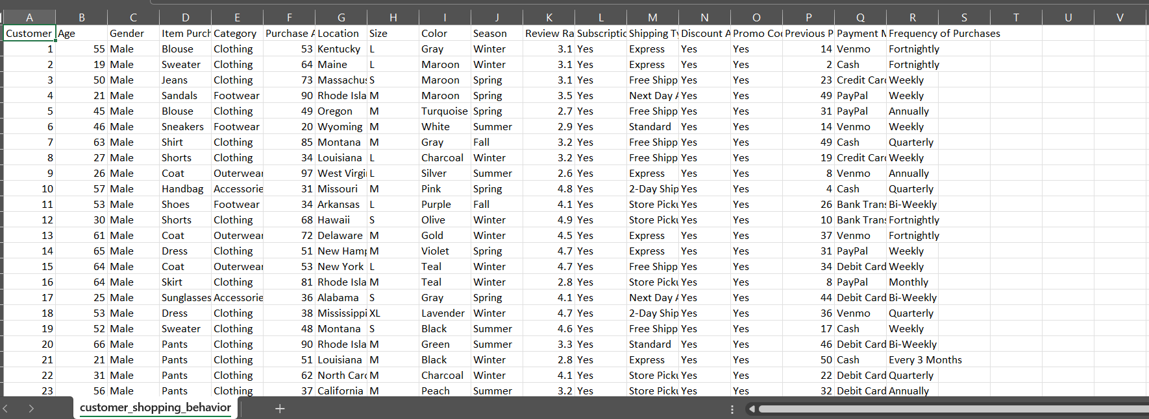
Figure 1: Preview of the raw customer shopping behavior dataset.

Figure 2 — Initial Data Inspection
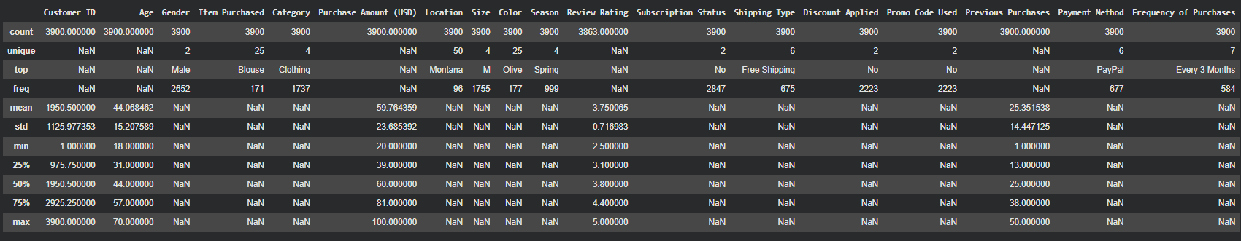

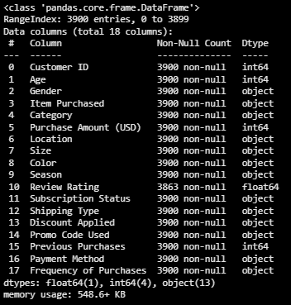
Figure 2: Initial inspection of the dataset using Pandas.

Figure 3 — Missing Value Handling
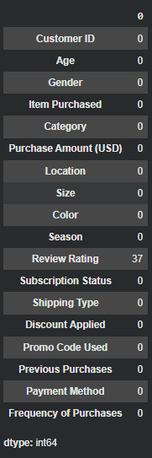

Figure 3: Handling missing values in the Review Rating column.

Figure 4 — Feature Engineering
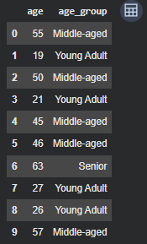

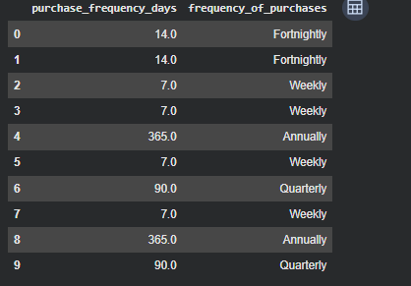
Figure 4: Feature engineering using age groups and purchase frequency.
Figure 5 — Neon/PostgreSQL Connection
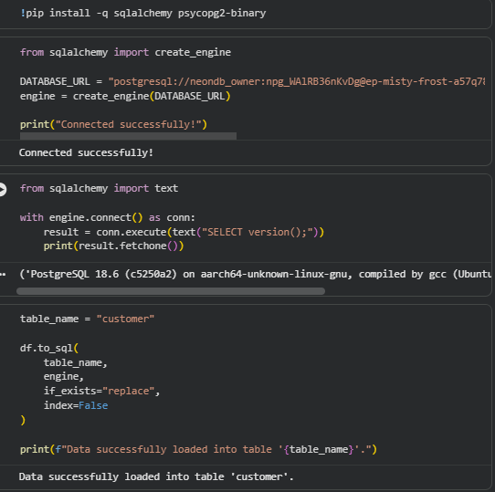
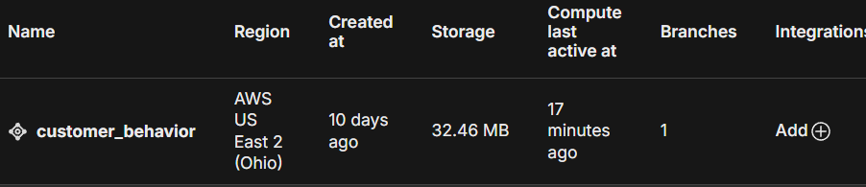
Figure 5: Successful PostgreSQL database connection through Neon.

Figure 6 — Customer Table
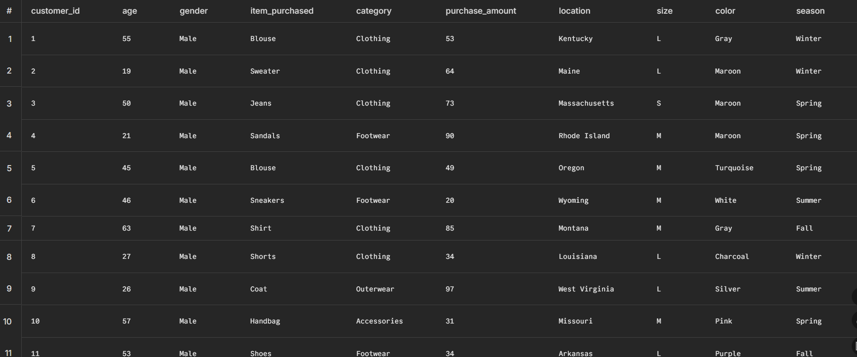]
Figure 6: Customer table stored in PostgreSQL.

Figure 7 — Dataset Count
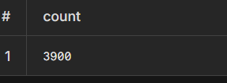

Figure 7: Total number of customer records.

Figure 8 — Q1 Revenue by Gender
[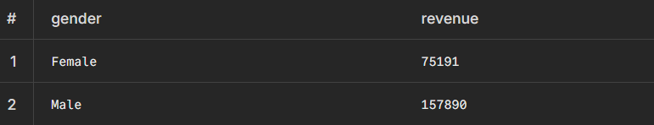
Figure 8: Revenue generated by gender.

Figure 9 — Q2 Discount Customers
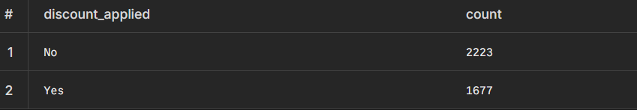Figure 9: Customers using discounts while spending at or above the average purchase amount.

Figure 10 — Q3 Product Ratings
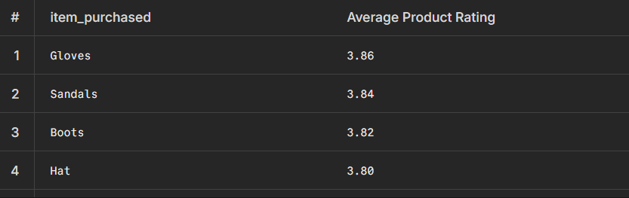Figure 10: Top products according to average review rating.

Figure 11 — Q4 Shipping Analysis
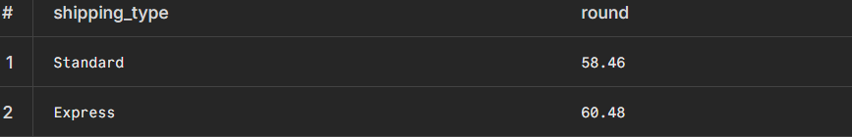Figure 11: Comparison of average purchase amount by shipping type.

Figure 12 — Q5 Subscription Analysis
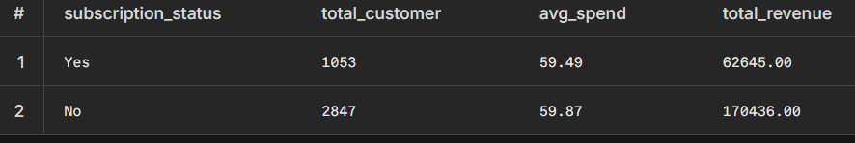Figure 12: Comparison of subscribers and non-subscribers.

Figure 13 — Q6 Discount Rate
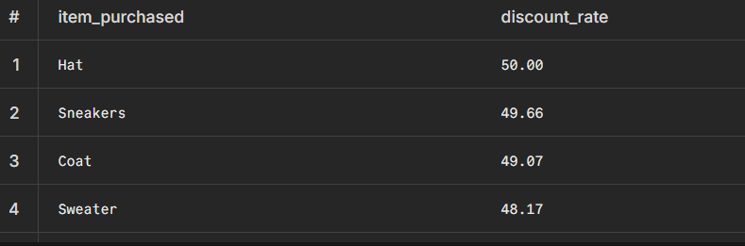Figure 13: Products with the highest discount rates.

Figure 14 — Q7 Customer Segmentation
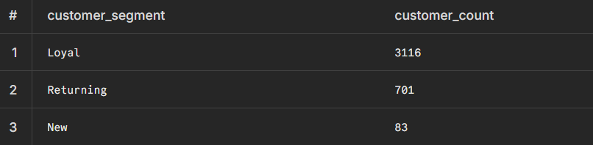Figure 14: Customer segmentation based on previous purchases.

Figure 15 — Q8 Top Products by Category
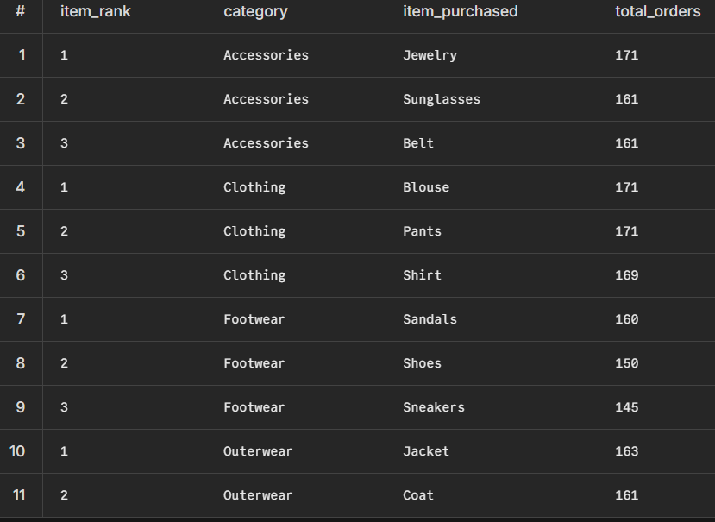
Figure 15: Top products within each product category.

Figure 16 — Q9 Repeat Buyers
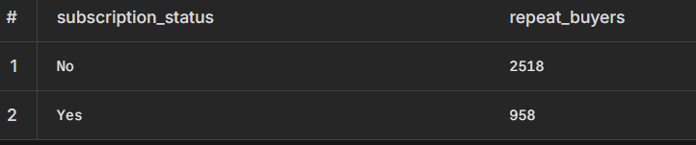Figure 16: Subscription status of repeat buyers.

Figure 17 — Q10 Revenue by Age Group
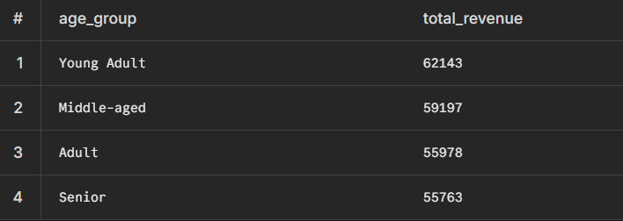Figure 17: Revenue contribution by age group.
Figure 18 — Power BI Dashboard
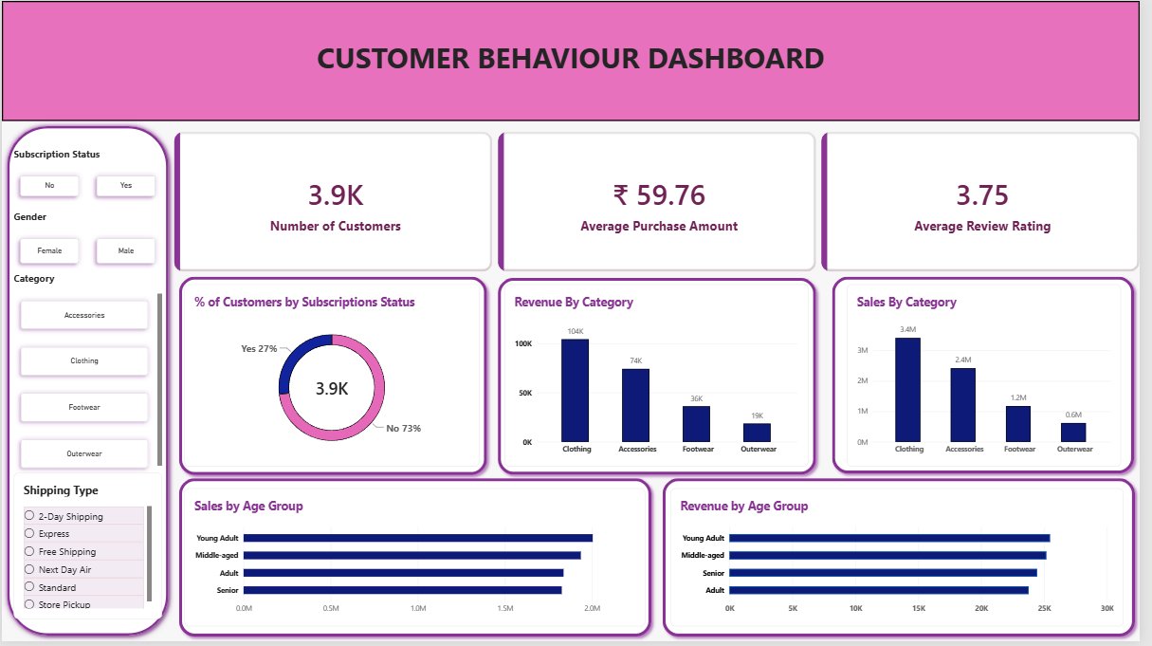Figure 18: Interactive Power BI dashboard for customer shopping behavior analysis.

Figure 19 — DAX Measures
Figure 19: DAX measures used for Power BI KPIs.

20. REFERENCES
- Python and Pandas documentation used for data preprocessing.
- PostgreSQL used for relational database storage and SQL analysis.
- Neon PostgreSQL used as the cloud database platform.
- Microsoft Power BI used for dashboard creation and visualization.
- Dataset: customer_shopping_behavior.csv

FINAL REPORT FLOW
Python → Cleaning → Feature Engineering → Neon → PostgreSQL Table → Q1–Q10 SQL Results → Power BI → DAX

